**Alice Super bubble**

Page 1:

Machine photo

***Deep Cleanse. Hydrate. Glow***

***Footer :***

***MAX cleansing (Max should be same as on machine )***

Page 2:

***Nourish, Oxygenate, and Glow Naturally with Alice Super Bubble***

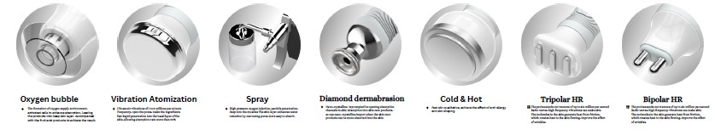

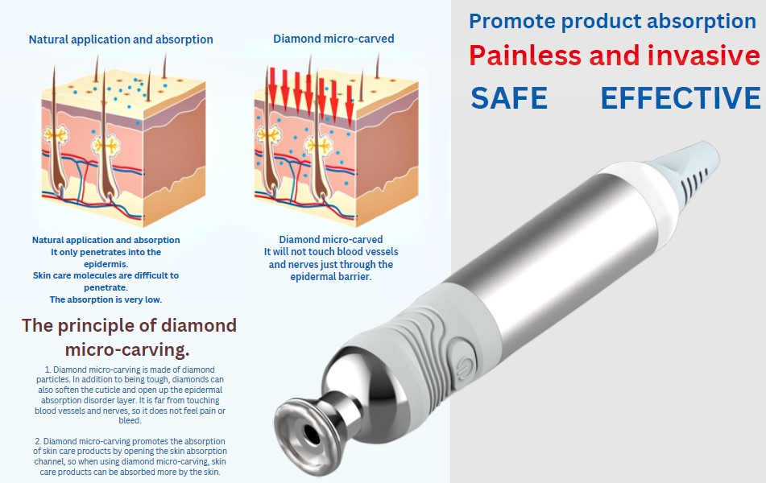

Put this on left side with design of skin

Right side add vacuum probe with skin layer and hydration

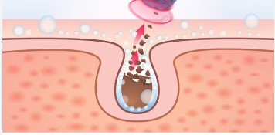

Add vacuum abrasion probe on top of this

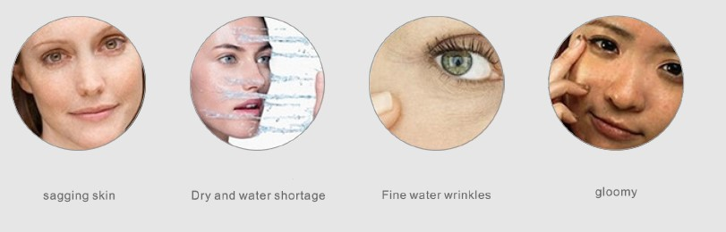

Add similar indications with photo

Specs table